# PROJECT DEVELOPMENT PHASE

**SPRINT 2**

|  |  |
| --- | --- |
| Date | 03-11-2022 |
| Team ID | PNT2022TMID14052 |
| Project Name | Real-Time River Water Quality Monitoring and Control System |
| Marks |  |

# SPRINT DESCRIPTION

In this Sprint, we completely explained about our executed NODE-RED PLATFORM with relevant Screenshots.

# NODE-RED SERVICE

* After Registering IBM Watson Iot Platform, now we move on to the Node-Red Service.
* Here we are about to create the User Interface through Node-Red
* All the requirements for the project are done in this platform

# DEVELOPED CIRCUIT

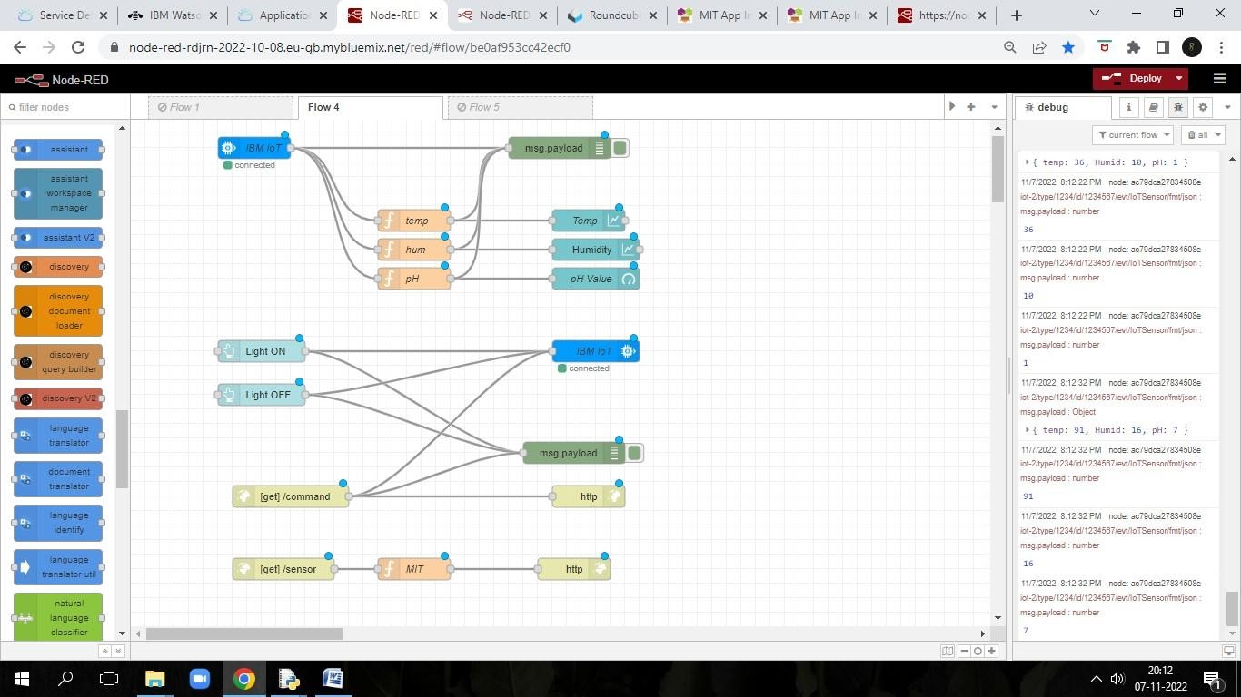

*Fig*. Above displayed is the circuit flow for the WEB UI and APP DEVELOPMENT

# WEB USER INTERFACE

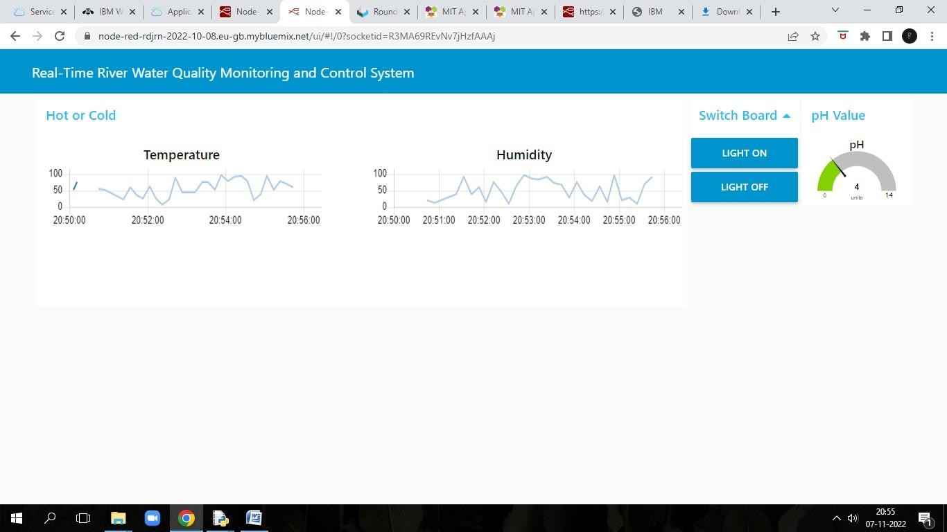

After the successful simulation of the Node-Red Service, User Interface is created. Our Web UI includes Temperature, Humidity, pH Value in accordance with Switch Board of Light ON and Light OFF.

# FINAL NODE-RED SENSOR WEBSITE

